**9. Comparison operators to find out whether a given number is greater than the user entered number or not.**

**Exercise**

* **Use comparison operators to find out whether a given number 28/56 is greater than the user entered number or not.**

**Approach:**

**So here we did like this**

**Take a number from the user and compare them using < / > and store it in the boolean data type because if you compare two operators it returns true or false**

**Solution 👇**

**Java :**

**import java.util.Scanner;**

**public class CodeXam {**

**public static void main(String[] args) {**

**Scanner ab = new Scanner(System.in);**

**int a1 = 28;**

**System.out.println("Given number is " + a1);**

**System.out.println("Enter number = ");**

**int a = ab.nextInt();**

**System.out.println(a);**

**boolean bool = (a1 >= a);**

**if (bool){**

**System.out.println("given number 28 is greater than your entered number ");**

**}**

**else {**

**System.out.println("given number 28 is less than your entered number ");**

**}**

**}**

**}**

**output:**

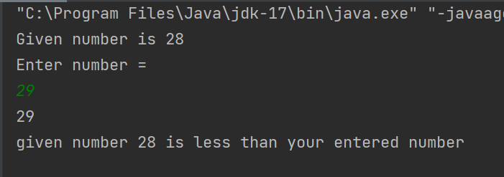

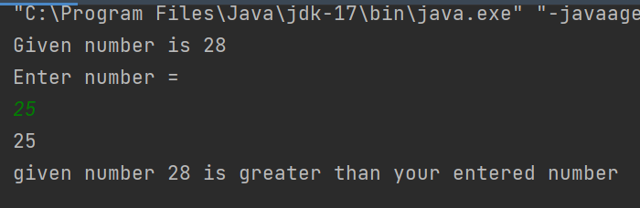

**Python :**

**given_number = 56**

**print("The given number is", given_number)**

**user_input = int(input("Enter your number : \n"))**

**if user_input < given_number:**

**print("Given number is greater than the entered number")**

**elif user_input == given_number:**

**print("Both are same number")**

**else:**

**print("Given number", given_number, "is less than the entered number")**

**output:**

